Урок английского языка в Музее Победы для медицинских классов
War Effort: Medicine
Рабочий лист

Introduction
Sum up the role of the Soviet Union in WWII based on what you’ve learnt in no more than 3 sentences.
Share and compare your ideas.

Task 1
Study the quotes by W. Churchill (Group 1) and F.D. Roosevelt (Group 2) on the walls of the Hall of Historical Verity. Are any of their ideas similar to yours?
Translate the quotes into English.
__________________________________________________________________________________________________________________________________________________________________________________________________________________________________________________________________________________________________________________________________________

Use the QR-code to compare your translation to the original quotes. To what extent do the texts differ?

Group 1
Group 2
Make a list of the vocabulary from the original quotes that you lacked in your translations:
__________________________________________________________________________________________________________________________________________________________________________________________________________________________________________________________________________________________________________________________________________
Add the vocabulary you find most useful to the Glossary.
What are the key points that Churchill and Roosevelt make in their speeches on the role of the USSR in WWII?

Task 2
Study the Soviet propaganda posters in the Hall of Historical Verity. What are their key messages?
Use the QR-code or the link below to see American and British propaganda posters. Identify the ones addressing medical professionals. What messages do they convey?
https://drive.google.com/drive/folders/1Rjv7l--qv_9P63PUrqi8pjK4LVug_609?usp=sharing
Pick one of the posters to compare and contrast with the Soviet poster of your choice. Use the following plan:
• briefly describe both posters;
• say what they have in common;
• say in what way they are different;
• say which one you find more impressive and explain why.
Do the task in pairs. Listen to your partner and comment on his/her talk. Mention:
- if you would add any information;
- if you agree with the conclusion; why/why not.

Task 3
Enter the Feat of the Army hall.
Read the inscription on the wall. What was the role of medical workers in winning the war?
Compare your ideas with the following passage. Complete the text by inserting the appropriate words into the gaps.
field / infection / injured / losses / mutilated / wound

In WW2, efficient medical care reduced overall _____ to only 4 in each 100 wounded (WW1 8 out of 100). Better surgery, penicillin, plasma and whole blood were responsible in varying degrees, however the credit must be shared by the entire personnel of the Medical Department, whose painstaking care, surgical skill and devotion to duty under difficult and dangerous conditions saved thousands of lives! The soldier with an _____ of his wounded leg, or with an open chest _____, or a _____ face, or an _____ brain, was certain to receive, after a short interval, the care of an orthopedic, plastic or neuro-surgeon – until he could reach his specialist. In general, the G.I. received the type of care which would get him to that specialist in the best possible condition. Army Nurses also gave widely varying types of skilled and sympathetic (often called Angels) service, some in _____ hospitals and others in general hospitals farther back. WW2 was also the first war in which Nurses automatically held officer rank!
(from https://www.med-dept.com/)
* American spelling is preserved.
Add the most useful vocabulary to your Glossary.
Task 4
Remember what you’ve learnt about the heroic work of medical personnel in the Feat of the People exhibition. Which activities would you call their everyday feats?
Read the article from the Moscow Mayor official website about the Medicine History Museum’s exhibition devoted to the Great Patriotic War. What does it add to the information you obtained from the Feat of the People exhibition?
Do the tasks after each part to learn more.
https://www.mos.ru/en/news/item/20520073/

Hard work and everyday feats during the Great Patriotic War
- An exhibition on the [Medicine History] Museum’s second floor is dedicated to Soviet medicine during the Great Patriotic War of 1941–1945. Opened in 2015 in the run-up to the 70th Victory Day anniversary, the exhibition features numerous multimedia devices, including interactive panels and multifunctional monitors. Visitors select their own guided tours, with the guide creating the appropriate atmosphere by controlling sound and visual effects by a tablet computer. This concept attracts young people and makes it possible to accommodate a large amount of information in a small area.

- True, false or not stated?
- The exhibition devoted to the medical feats was prepared after the 70th Victory Day anniversary.
- Guided tours can be adjusted to the visitors’ tastes.
- Young people attend only interactive exhibitions.
- But traditional stands provide the strongest impressions. A military hospital located in the central section of the Frontline Hall symbolises the effective medical assistance system streamlined by Soviet military doctors. All Soviet medical personnel had their own clear tasks. Orderlies and nurses bandaged soldiers and evacuated them from the frontline as quickly as possible. Doctors examined wounded soldiers at medical battalions and acted according to the situation. Emergency onsite surgery was performed, some soldiers were treated at medical battalions and others were sent to large hospitals behind the lines or received disability retirement. This system made it possible to return up to 70 percent of wounded service personnel to active duty.

- What were their responsibilities?
Copy the duties into the appropriate columns: bandaging, evacuation, examination, operating.

Orderlies and nurses | Doctors
|
|

- What can you see in these pictures? What do you think their connection is to the medical issues of wartime?
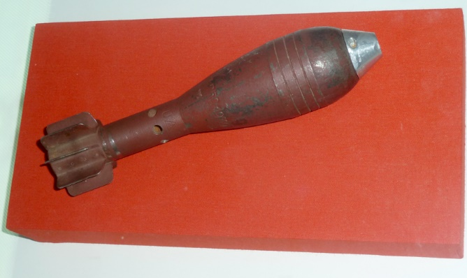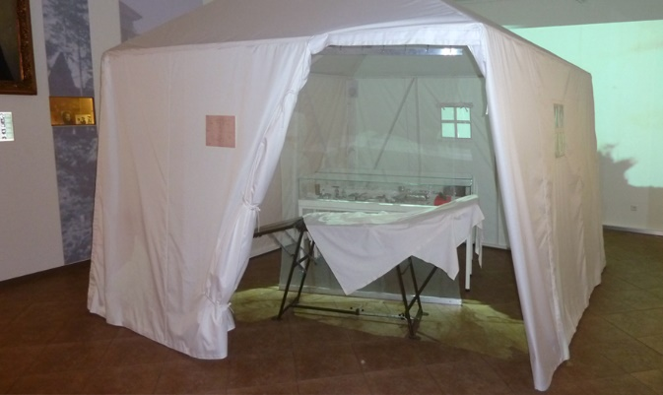

- Here you can see a 50-mm German anti-personnel mine inside a tent. In 1942, military surgeon Arkady Razdyakonov, a graduate of the First Moscow Medical Institute, removed the mine from a machine gunner’s leg. Operations like this were extremely rare during the entire war. As the mine could explode anytime, an orphan nurse volunteered to assist. The operation proved successful, combat engineers defused the mine, and it became a family relic. In 2013, Mr Razdyakonov’s son gave it to the museum.

- What’s that? Can you determine the origin of this object? What role might it have played in a medical emergency?
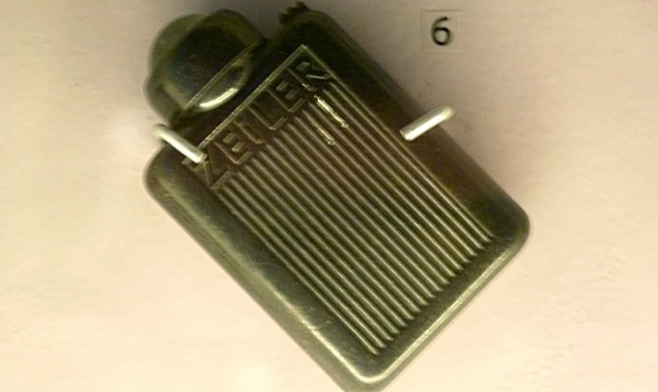
- This captured German flashlight seems out of place at a stand dedicated to female doctors at the front, but it made another medical feat possible. A Red Army soldier used the flashlight to illuminate the abdomen of his friend who was wounded in Berlin after its capture by Soviet forces, while doctor Yelena Makeyeva operated on her patient on a local street. Her hospital was about to redeploy, and the wounded soldier was fortunate because doctor Makeyeva had her medical bag on hand. The soldier recovered and wrote to his saviour many times, thanking her, and she kept the German flashlight for many years.

- Identify the objects in the picture. How may they have been used for medical purposes during the war?

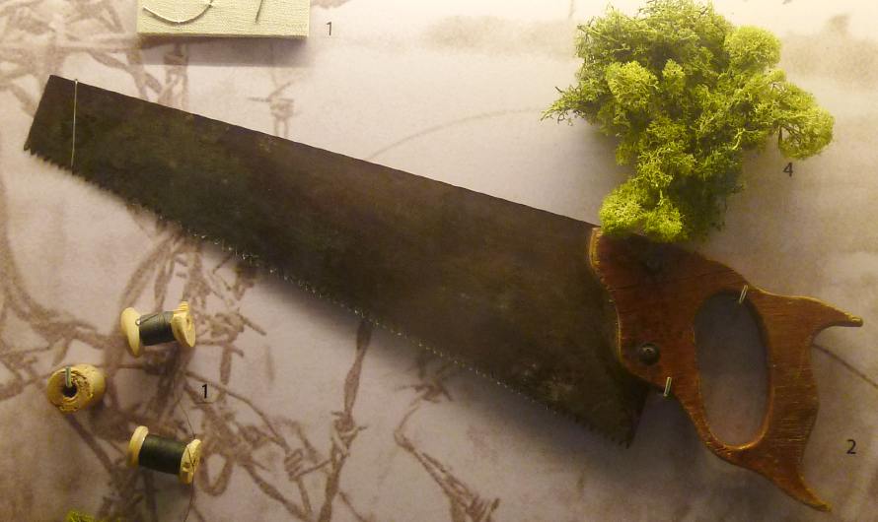
- Another stand has no authentic exhibits, but nevertheless reflects historical truth. Table knives served as scalpels, joiners’ saws were used for amputations and moss and wires helped to effectively dress wounds. All this was recreated through the recollections of Doctor Sergei Altayev, another First Moscow Medical Institute graduate who spent almost the entire war at a camp for prisoners of war and who continued to treat other inmates there.

- Identify the following in the pictures (A – D):
abdomen pain, saw, scalpel, wound dressing.

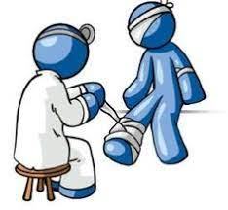  A _________________________ | 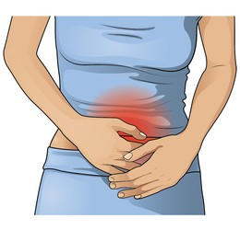  B ________________________
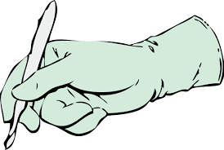  C __________________________ | 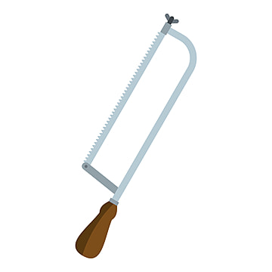  D ________________________

- The museum’s exhibits can tell us about many miraculous recoveries and heroic feats. But many heroes would simply shrug off these stories because, in their opinion, they were simply doing their job.

- Find the mentions of these people in the article. Who does each article of information refer to?

 | First Moscow Medical Institute graduate | Removed a dangerous object | Operated outside | Worked while imprisoned | Had help from a non-medical assistant
Arkady Razdyakonov
Yelena Makeyeva
Sergei Altayev

- Which idea do these people’s stories illustrate?
- First Moscow Medical Institute was the best education facility to study medicine before the war.
- The museum’s collection largely depends on contributors who participated in the war.
- Soviet doctors and other medical professionals managed to fulfil their duties even in dire circumstances.
- These doctors changed the principles of emergency treatment.

- What does the phrasal verb “shrug off” in Paragraph VII mean?
- to move one’s shoulders
- to treat something as unimportant
- to feel shy and ill at ease
- to be proud of something

Work on your Glossary: add useful vocabulary from the article.

Task 5
Divide into three teams and take a quick tour around the Feat of the Army hall to take notes on the following:
Team A: what kind of injuries could be caused by the weapons presented;
Team B: what kind of obstacles medical professionals had to face while doing their jobs during the war action;
Team C: what kind of medical issues and disruptions in medical care people had to face during the Siege of Leningrad.
Get back together and exchange information.
Injuries | Obstacles | Siege Medical Issues

Task 6
Regroup and discuss the following:
- sum up the major difficulties medical professionals had to overcome during the war;
- think of the key changes that have taken place in the medical sphere since the war;
- how can the issues you’ve discovered be resolved today considering scientific and technological progress?
Present your work to other groups and compare ideas.

Task 7
Return to the Hall of Historical Verity.
Find the infographics titled Freedom for the West, Salvation for the East.
Write a report based on the presented data and add a section on the contribution of medical professionals based on what you’ve learnt during the day.
Use the following plan:
– make an opening statement on the subject of your report;
– summarise the information by selecting and reporting the main features;
– make comparisons where relevant;
– give an overview of the medical professionals' contribution to the war effort;
– draw a conclusion.
Check out additional tasks in the Case files.

